|  |
| --- |
| Tutorial 8(Week starting on 9-may-2022) |

|  |
| --- |
| **Objectives**   * Continue studying the Industrial Revolution and the Great Divergence * Analyze debates among academics and how knowledge is built * Replicate graphs from a research paper   **Working materials**   * **Humphries, J. & J. Weisdorf. [2019]** “Unreal Wages? Real Income and Economic Growth in England, 1260-1850” *The Economic Journal*, Volume 129, Issue 623, Pages 2867–2887 * **R** and **RStudio** * You will need the file “Ejercitacion 7 HE.R” * You will need “FigCinco” and “HWFigura2” **databases** which can be found on the virtual campus[1]. |

**Exercise guide**

The exercises marked with an asterisk (*) are compulsory and must be submitted by email **before 12.00 on Wednesday 18th May**. [2] To the mark obtained on the evaluation of this assignment,**0.05 points will be subtracted for each minute late**. Consult the course program with regards to the formalities of the presentation.

1. (*) Explain in a few words what is the question Humphries & Weisdorf [2017] are trying to answer. What are the main results?
2. What are the two main explanations for the evolution of economic development in the long run? What are the two explanations cited by the authors to explain the difference between real wage and GDP? Explain concisely in your own words.
3. According to the authors, the discrepancy between real wage and GDP per capita (and thus, the discrepancy between the Malthusian and Revisionist views) can be reconciled by focusing on variations in annual income caused by changes in individual labor supply. What problem does the authors argue exists in testing this empirically? Think about the assumptions that must be done. What is the author's proposal to solve this problem?
4. Replicate Figure 2 of the paper. Explain in detail what this figure represents (what data are represented, period, and so on). What are the three conclusions that the authors derive from this graph?
5. (*) Replicate below figure (which corresponds to Figure 5 of the working paper, available at <http://www.ehes.org/EHES_121.pdf>) using data from the "FigCinco.xlsx" database.[3] Explain in detail what this figure represents. What does the graph show and what can we conclude from it?

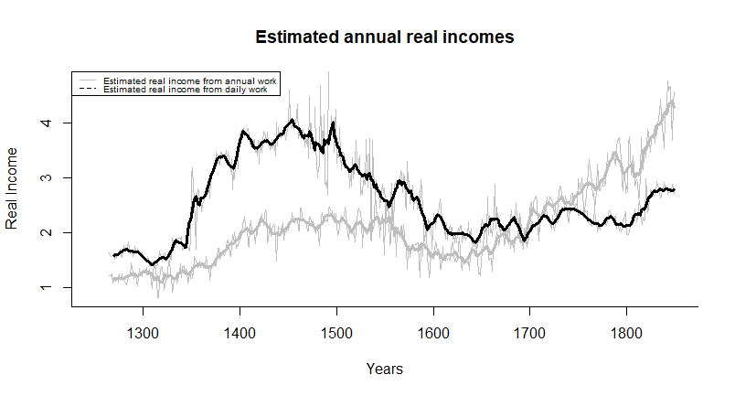

1. (*) What do the authors have to say about the hypothesis of an Industrious Revolution as proposed by De Vries? Take a look at Figure 4 of the paper in its published version (Fig. 4: *The length of the working year, 1260-1860*.).
2. The question they are trying to answer is how and when people actually got richer in the western world. They focus on the two divergences between GDP and wages throughout history, during the 18th century and during the black plague and propose that the 250 days Allen supposes as the annual days worked in his estimates weren’t constant. Therefore, they differ from Allen’s view through data on annual wages of unskilled workers. Through this they try to infer days worked by workers employed by the day. They find that, measured this way, Allen was estimating too low an income after the 18th century and too high an income during the black plague and that with the industrial revolution, GDP and salaries began to equalize (because people were working more days). This means that the rupture from a Malthusian equilibrium would have happened before what Allen would suggest and instead began in the XVII century with an Industrious revolution.

5. From this graph we see that wages typically vary across studies and, also, they themselves were extremely variable (seen in the clearer lines of the graph), therefore a more stable approximation is obtained by averaging wage data. The paper says wage data are from unskilled workers hired yearly, thus it is logical to see a jolt in annual wages by the Industrial Revolution and daily wage labour rates lagging. Still, annual contracts were not as valued as daily work

6.The authors’ position on the “Industrious Revolution” is that the hypothesis would account for the changes in worker’s preferences that goes into the paper’s main point. De Vries’s model, then, would confirm Allen’s paper doesn’t measure that preference switch as it takes a fixed number of labored days. This point is made to show in Graph 4, which portrays there was an increase in annual labor input per worker.

1. The databases were created from the databases available in the appendix of Humphries, J. & J. Weisdorf. [2017] “Unreal Wages? Real Income and Economic Growth in England, 1260-1860” EHES Working Paper No. 121 European Historical Economics Society.
2. Check the course’s syllabus on presentation
3. This figure is not present in the published version of the paper, but it is present in the Working Paper 2017 version, which can be accessed by following the corresponding link.